DEVELOPING CREATIVITY IN CITIZENSHIP EDUCATION.

Objectives
At the end of this chapter you will have:
- Reflected upon the possibilities of using creativity in your classroom practice in the delivery of meaningful and exciting citizenship based education:
- Considered creative strategies that work in a range of learning contexts by effectively engaging all students on a variety of different levels:
- Reviewed how popular culture can be used to enhance the quality of creative teaching and creative learning in your classroom:

In this chapter I will be reporting upon a range of radical classroom strategies that have synthesized and integrated elements of creativity with Citizenship teaching. These strategies will have a strong focus upon student engagement in a classroom based environment.

Currently, as it stands in the world of education, there has been a marked decline in the presence of creativity within the curriculum. This is of course a lamentable loss of opportunity for both, students and for teachers alike. The shift away from creativity has significantly moulded and shaped the rather pedestrian and mediocre curriculum which is now so prevalent within most academic institutions and centres of learning:

‘Teachers now have no time to engage children in free thought, and, sadly, there is now no time to allow children to think for themselves. Creative subjects do this, of course, but look what happened to them. The national desire for data has seen these subjects squeezed to the point of submission and we now have a national curriculum which has placed the creative subjects into a straitjacket to be loosened at your school's peril’ (Colin Harris 2016 TES cited in bibliography)
This has been led and informed by policy changes which have sought to re-model the curriculum fuelled by a number of fiscal imperatives which have fragmented and fractured a holistic curriculum which was once the entitlement of all. We now inhabit a curriculum of cloven hemispheres, viewed through a labyrinthine series of binary oppositions in which creativity and innovation are seen to be at variance with academic rigour and serious study. This dichotomy is of course false and entirely unhelpful and is in urgent need of repair and restoration if young people are to access once again a full and equal curriculum entitlement.

There are of course always exceptions but it does take courage and determination to swim against the tide of prevailing educational wisdom currently. The decline of the creative arts within the curriculum, partly driven by the diminishing value placed upon creativity, and partly driven by the need for students to be seen to be taking more ‘academic’ subjects has redefined the current educational landscape.
Creativity, risk and enjoyment have been replaced by mediocrity, fear and accountability measures and in this climate, creativity and innovation naturally fades, diminishes and withers into oblivion. However, there is hope and in the words of Albert Camus ‘in the midst of winter, I found within me, an invincible summer’. This ‘invincible summer’ is the spirit of hope and determination which drives innovation and creativity and is woven into the being of all educators who take risks, who create, innovate and push their students towards finding their vocation in life. As educators, we all have a duty to enshrine and to preserve creativity and innovation in everything that we do in the classroom, and we have a duty to swim against the tide of prevailing educational wisdom. It is possible to be both creative, innovative and to be outstanding as well as ELAM (East London Arts and Music) testifies to the power of creativity to change young people’s lives. ELAM was judged to be outstanding in 2017 by OFSTED and as a free school it does offer to young people a full and balanced curriculum. Its intake is from a number of deprived wards with multiple deprivation indices and yet it is through the arts and through creativity that the students are able to find employment and are able to enhance their life chances and opportunities. A school like this , in order to be successful, has received a large amount of funding and financial support from the creative industries and yet against the odds it has thrived and flourished. This has been partly driven by a strong moral imperative and by the need to offer to students a creative curriculum closely linked to employment opportunities in the creative industries.

Interestingly enough, in recent figures published in November 2018 by the DCMS, (department for digital culture media and sports) it is recorded that the creative industries are worth £101 billion to the UK economy, and this is an increase of 53.1% since 2010 when it was £66.3bn. Ironically it would appear that the creative industries are thriving and are making a substantial contribution to the economy precisely at the time when the creative curriculum is shrinking and receding. This is clearly indicated by recent statistics from within education which indicate a drop in the number of students taking arts related subjects based upon exam entries, further supported by well publicised redundancies for teachers and practioners of the creative arts. Also there has been a well publicised shrinkage of the curriculum time allocated for such subjects. In April 2017, a NASWUT document entitled Creativity and the arts in the curriculum, measured the decline in teacher numbers for creative arts subjects. In the case of art and design, the teacher headcount dropped by 13.7% and in music it dropped by 13.8%. For media there was a drop of 18.2%, drama was down by 19% and design and technology was down by 22.3%. According to a report published by The Culture Learning Alliance in 2017 , between 2010 to 2017 there has been a marked decline of -28% in the number of arts GCSE entries (Art, Design. Dance, Design and Technology. Drama, Media/Film/TV Studies, Music and Performing/expressive arts). Entries for these subjects have dropped from 673, 739 in 2010 to 485,326 in 2017. This is a huge concern since many of these subjects offer a cluster of creative skills and processes which are therapeutic, which build resilience, innovation and which naturally feed into the emerging creative economies, both locally and nationally. It would appear to make no sense to reduce the presence of these subjects within the curriculum precisely at a time when there is a crisis in mental health amongst young people and precisely at a time when working patterns are changing and shifting constantly.

In a way the spirit of creativity is retreating more and more and an ironclad curriculum, which, by its very nature is monolithic and immovable, fuelled by market forces and driven by very traditional notions of employability, is now so prevalent as the dominant paradigm of collective wisdom. This whole enterprise ignores the presence of creativity as human capital and this will disenfranchise a significant minority of young people who are keen to join the creative industries to seek employment. By 2030 it is predicted by NESTA (Creativity and the future o skills 13th November 2018) that more and more occupations will be asking for creativity and that by implication policymakers needs to be investing in the workforces’ creative skills more effectively. This will of course have implications for school curriculum design and this will create a pipeline issue by which young people do not have the skills they need for employment in these creative industries because the pathways they need to follow no longer exists.

It is through the lens of creativity that Citizenship should be viewed since engagement in the classroom is integral to raising the position of the subject by offering to all students who take this subject, niche experiences which are hard to replicate in other subject areas. These experiences, by their very nature, will be transformative and engaging, thought provoking and life affirming and they are all to do with making a difference and bringing about social change and a shift in consciousness in the way that we think. Citizenship desperately needs to be rescued from mediocrity and from a sense of all pervasive greyness which is in danger of extinquishing the flame and the fire of creativity which burns brightly within this curriculum area. The obstacles presented by the current curriculum model are not insurmountable and there are no such things as immovable objects but it does need to be challenged by senior leaders, teachers, parents and by communities who recognise the centrality of creativity in their communities. It is important to be able to balance a number moral imperatives related to the importance of creativity and the arts despite the fact that the current curriculum model is driven by a number of fiscal imperatives. These imperatives are related to employability and to the enhancement of life chances bound to a very limited set of career trajectories and pathways which ignore and negate the creative arts and the creative industries.

Interestingly enough in April 2017, NASWUT commissioned Creativity and the arts in the curriculum, and this report looked at the existence and persistence of creativity within the curriculum and this is significant given the public discussion about the withering of skills and processes and the veneration of knowledge and rote learning. It is within Citizenship that many of these skills and processes can be nurtured without losing the knowledge content of this subject since creativity and innovation are two branches of the same tree with firm roots established in this key curriculum area:

‘For the purpose of this report , creativity is understood: to include ‘creative teaching’ and ‘creative learning’, which may be used to address challenging topics and themes that do not fit under traditional subject headings, such as sensitive issues around sexual violence and abuse, or rights and responsibilities, including those relating to equality and social justice, sustainability and global learning’ (Creativity and the arts in the curriculum p4).

In my own teaching experience and practice I have always endeavoured to reach out to students in various classroom settings by offering and presenting learning experiences which connect with their own familiar life experiences. In the context of Citizenship this is something which is a philosophical imperative given the close relationship between its subject content and the contemporary themes which are covered. One of the most effective resources I have used in numerous classroom settings has been the track performed by the artist Dizzee Rascal called ‘Love This Town’ which was released in 2013.

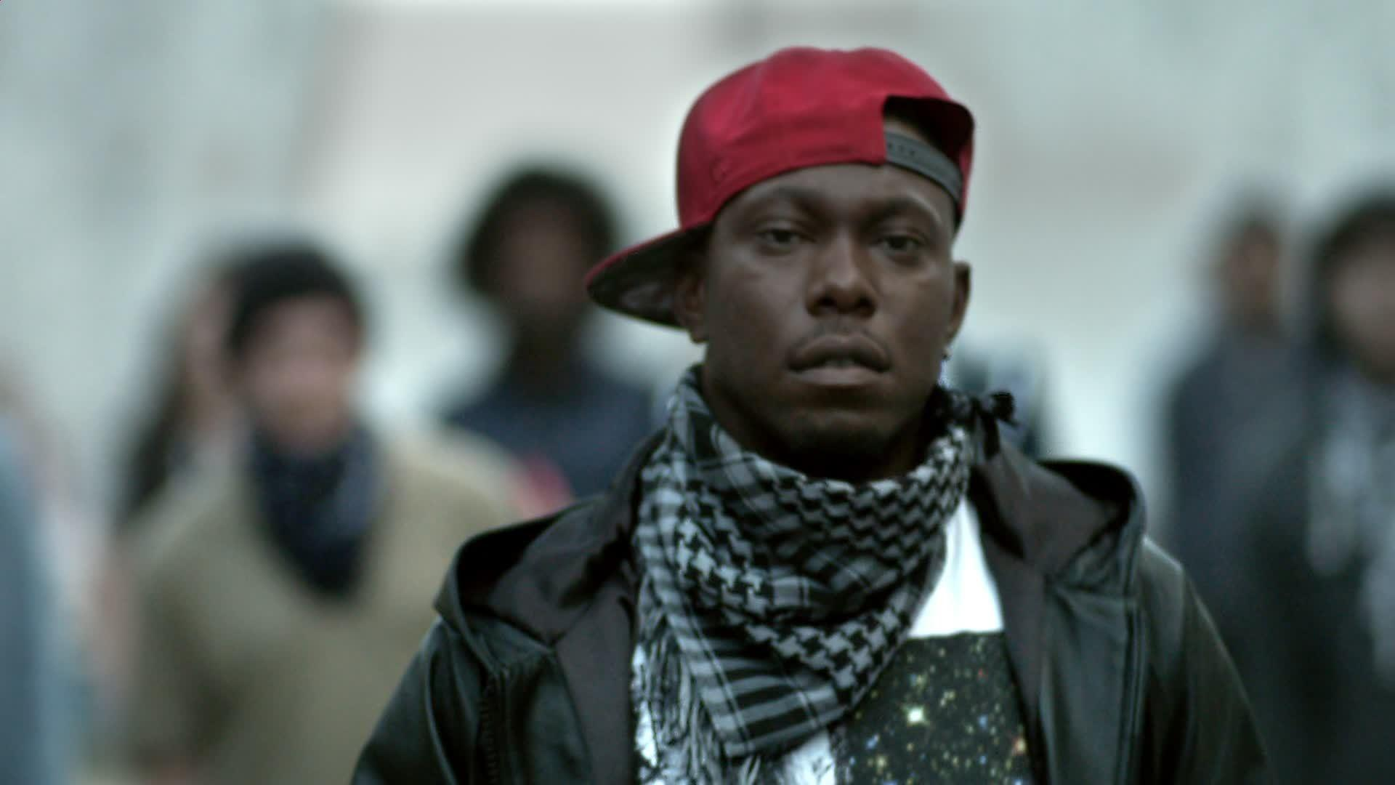

The video exemplifies the whole citizenship enterprise visually, and represents the importance of the subject since it is a parody of the 2011 London riots and very cleverly reverses the events of that time. It marks and indicates a significant movement away from anti-social behaviour towards prosocial behaviour. It offers a model of what could be and what should be in terms of young people playing a positive part in a civil society and how they are hampered and impeded by negative stereotyping and how it is important to break through these labels. The video highlights a number of key altruistic acts which are carried out and initiated by young people through a series of vignettes which challenge and make the audience think differently about social action and social engagement.

This video and piece of music work together really well as an introduction to Citizenship since the images highlight the importance of taking responsible action to change something within the community and communities we all inhabit and live within. The video is extremely well constructed since it takes recognisable events from the media coverage of the 2011 London riots and reverses them and challenges the viewer to see things differently. This again is exactly what Citizenship is about. The video explores issues related to the representation of young people, and is something which, without any doubt will always entice students into a discussion through a series of thought provoking responses to the issues that Citizenship raises and seeks to cover. The use of the video and the track will always connect with student’s own experiences and is frequently used in assemblies and in the classroom to highlight the centrality and the importance of altruism in defining our humanity in a number of different contexts and situations. This video can be used for the Taking Action part of the GCSE Citizenship (Edexel specification) course since it clearly highlights the difference that individuals can make by participating in responsible action and is the perfect antidote to apathy and to disinterest which can be all persuasive and all consuming at times within our contemporary society. An act of kindness motivated by altruism can build an alternative model of social and human interaction and communication in which one good action can be shared with a large group of people within a community until this becomes an unstoppable wave of good will. This concept relates to the novel Pay It Forward by Catherine Ryan Hyde in which a young boy does a good deed for another person without any expectation that this action is returned back to him but upon the condition that this is passed on to three additional people and by doing this each person weaves a chain of kindness. Hence the title, ‘Pay It Forward’. The student is given an assignment by his social studies teacher and in America this subject would be the equivalent of either Sociology or Citizenship and he manages to make a difference to the community that he inhabits. This enterprise is not without its risks and its flaws but essentially it is about the motivation and the intention to do good and to transform society from within.

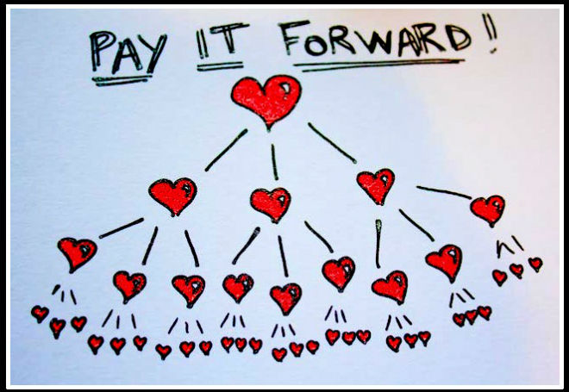
This also resonates with the ideas contained within the Dizzee Rascal music video since the young people in the vignettes are modelling good deeds and good actions which will inspire other young people to pick these ideas up and to implement them in their own social settings. Effectively these actions offer a very different model of being which is based upon good will and the exchange of human capital motivated by altruism and the need to improve the lives of the people who live within our communities and beyond.

Another resource which extends these ideas further is a piece of music by the American collective Black Eyed Peas and this track entitled ‘Where is the love’ (2016 remix) contains many ideas which also resonate further with the enterprise of teaching Citizenship. This piece of music is poignant since it offers a range of images and visuals which connect the audience with World-wide issues and problems. The track is poignant and it never fails to engage students since the images are powerful and thought provoking and the questions asked during the music video are relevant and pertinent to the subject contents of Citizenship. This resource is an invaluable prompt for any work on Human Rights and Human Wrongs and can be used to ignite discussion about the absence of basic rights for key cultural groups across the World today. The relevance of the track today in 2019 is as relevant as 2003 when the track was first released since it is a sad indictment of humanity and of our collective failure to live together harmoniously and without conflict.
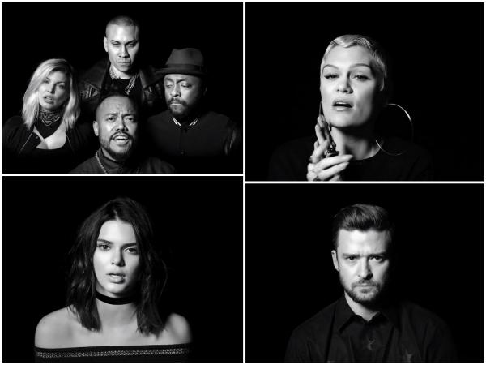

The lyrics for the track can be used as a prompt or further discussion and students could work on re-imagining the lyrics themselves to produce a different version of the track by engaging with the subject content of the music. This could be an activity linked to how the media represents and miss-represents key events in the World and it could also be used to look at migration, immigration, community cohesion and the need to understand the wider context through which everyday events are framed and viewed. This resource could also be used to link into the idea of ‘Taking Action’ on a bigger global issue which affects the local community.

In the context of looking at ideas in relation to the notion of Multi-Culturalism and the idea that Britain is a ‘melting pot’ of different cultures there are a lot of examples from contemporary popular culture which can be used to illustrate the importance of embracing diversity and difference. In this activity, examples of popular performers and musicians are presented to the class and students are invited to identify the names of these celebrities and to try to infer where these individuals originate from.

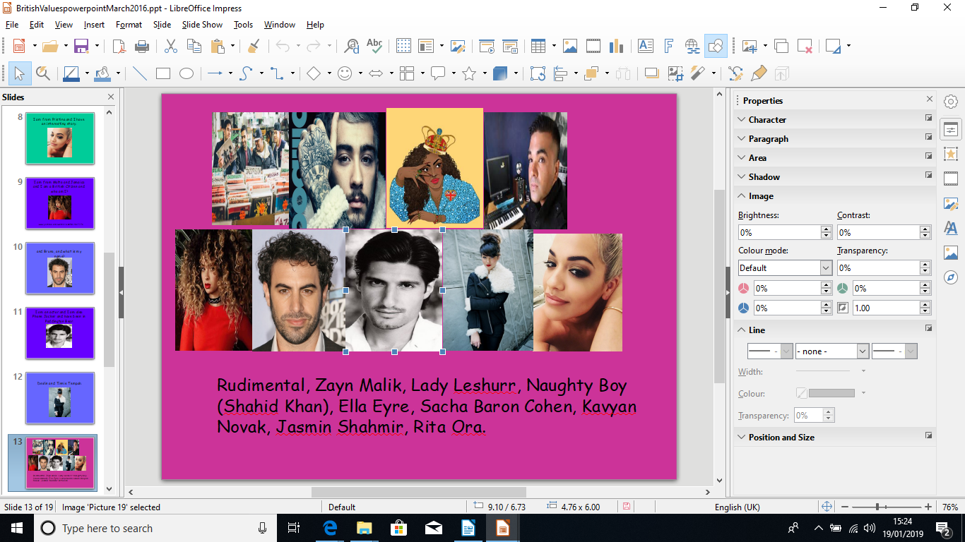
The list of celebrities can be changed and updated regularly to keep it relevant and up to date. One of the most striking icons of what it is to be British will be Rita Sahatçiu Ora who will be well known to many of the students that you teach from the television series The Voice. In reality Rita Sahatçiu Ora ( is in fact a refugee from Pristina in the former Republic of Yugoslavia) and she was forced to flee from her own country when she was very young since she was an ethnic Albanian and a Muslim. This will inevitably prompt discussions and debate and will highlight the fact that our culture is made up of a lot different elements from a range of different countries. This piece of work can also be used to look at the idea of identity and how we create a sense of self in relation to ethnicity and culture.

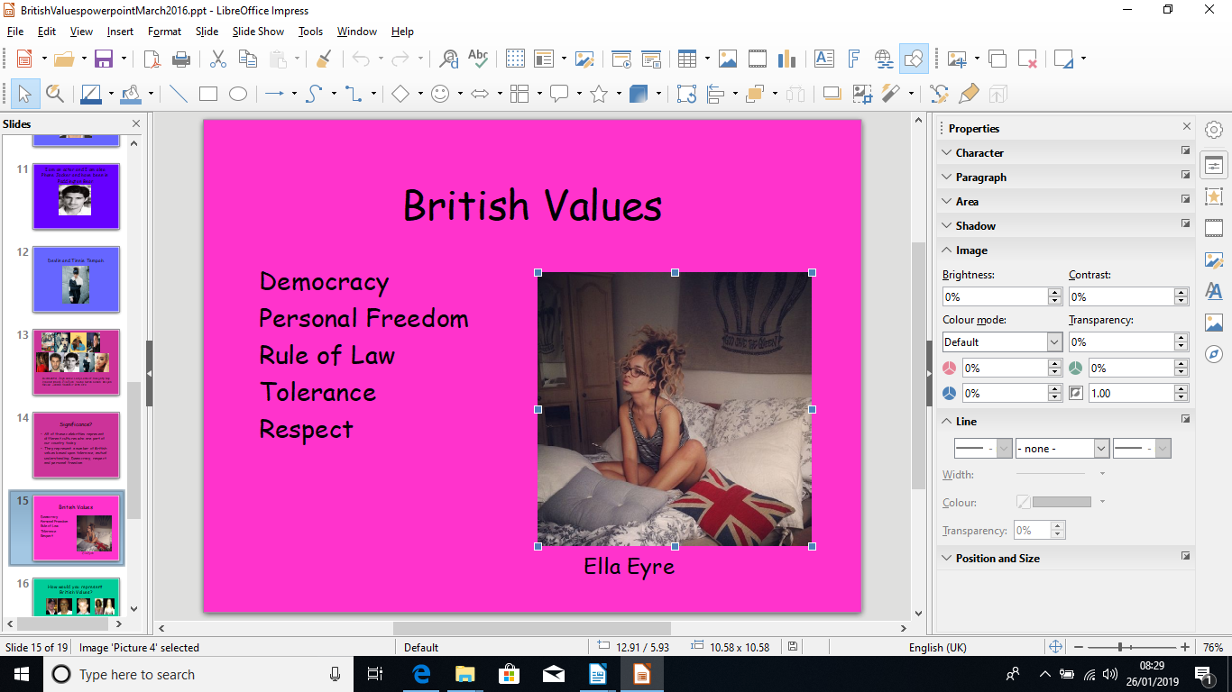

An artist like Ella Eyre is also a useful link into this topic since she is a well known performer and she also had a complicated ethnic profile which means that she is British first and foremost but she also has a complex identity related to her Jamaican, Irish and Maltese roots and origins and again this will make the students view their own identities in a different way. It is also possible to play her music and to use this as another prompt for further discussion and exploration. This will encourage the idea that our society is a rich mix of different cultures and groups. All of these references to different performers from a range of different cultural backgrounds could be consolidated as a mix tape so that students could engage with the idea that our culture is made up of different elements and components through a medium they will all b familiar with. There are USB mix tapes available which could be used for this purpose and the idea would be to show the rich layers of culture which artists add to our culture and society through music and performance. The Students could make up their own mix tape and each student could add an individual track which they have chosen to add to a class mix tape which celebrates the cultural diversity within the communities they inhabit.



Another relevant resource which would further highlight the cultural diversity of the society we live within, is related to the origins of a well known fashion cultural icon. The designer Ralph Lauren was actually born in America but his origins are in fact to be found in Belarus in Russia. His parents were originally Jewish immigrants who fled Belarus in the late 1930’s and Ralph’s family name was Lifshitz which he changed to Lauren when he was a teenager. Again this highlights the diverse society we live in and further underscores the fact that many of our contemporary cultural icons are in fact from many different cultures and backgrounds and together they add rich layers of experience to our existing culture.
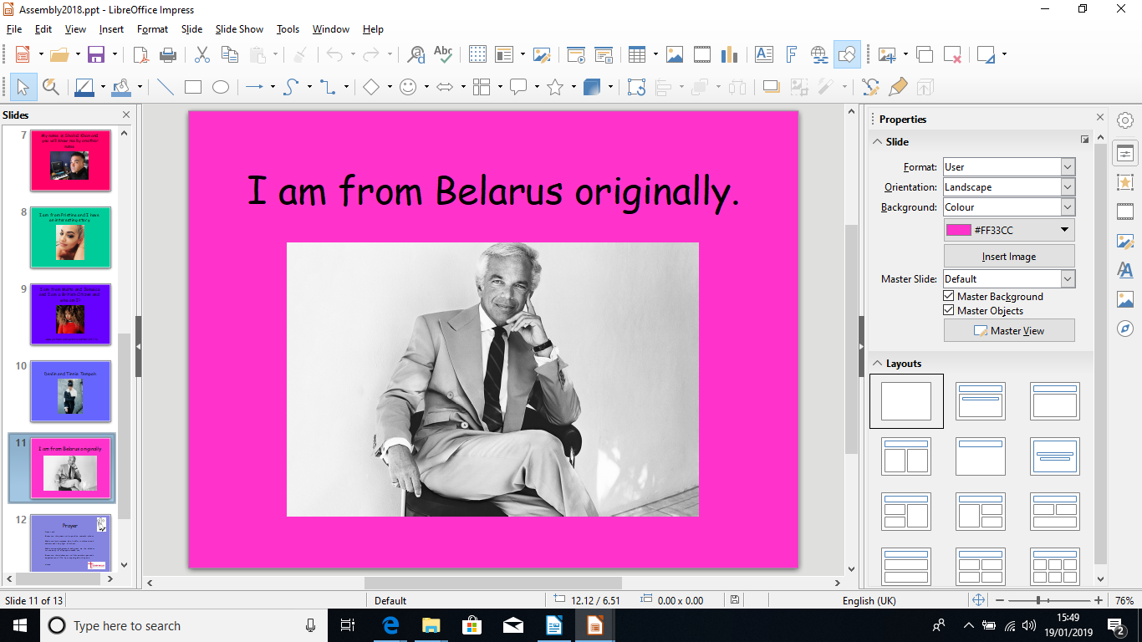

This is another way of engaging with students creatively and will make them think differently about the world around them and the people they relate to and know about. Many of your students will be familiar with the brand Ralph Lauren , but few if any, will know the cultural origins of the designer himself and this will present a surprising and unexpected cultural narrative. Through this example they will understand the rights and entitlements of all people to thrive, flourish and be successful in a just and equitable Society. This will challenge many students to think differently about their own prejudices since by wearing this brand they will be participating in complex cultural narratives of migration and displacement.

An activity which further links into the idea of community diversity and community cohesion and the need for acceptance is related to the CRE (Commission For Racial Equality advert) ‘Would I’ advert campaign. This was a campaign from the early 2000’s which took a group of well known celebrities and changed their ethnicity and race to ask the audience basically does race matter?. The advert also asked the question about if race defines and limits us and makes any difference to how we are treated in Society. The advert has recently re-appeared on you-tube (www.youtube.com/watch?v=etmRx9rIGUU ) and could be used as a prompt for a consideration of racial diversity and the need to think beyond skin colour and ethnicity. This lesson could be used as an introduction to community cohesion, living together or to identity and students could design their own adverts which would promote diversity, acceptance and community cohesion.

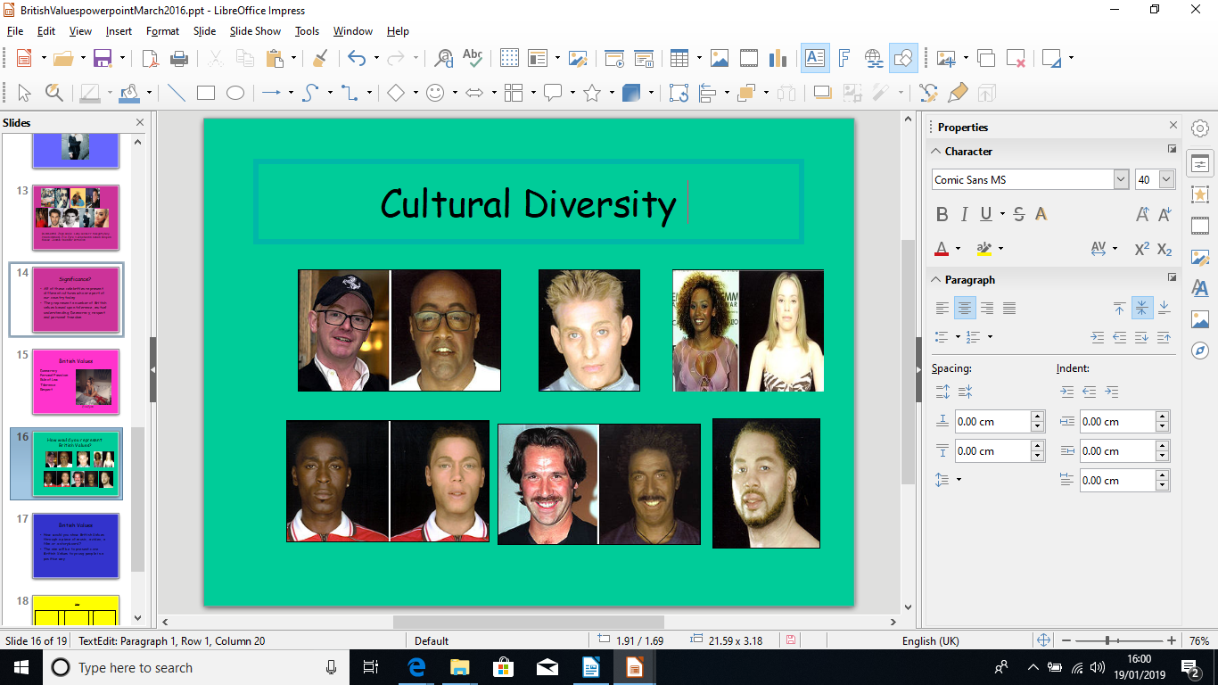

The original advert was created by the team who created the film Gladiator and it used cutting edge technology to change the racial identities of well known celebrities to question racism, discrimination and prejudice. The advert will generate debate and discussion and could be linked to the BBC series Trading Races which involved an experiment through which people changed ethnic identity and walked in the shoes of another race to feel and to understand this experience. This experiment is of course indebted to the work of John Grifffin who in 1963 went undercover in America as an African-American to explore race and prejudice during the rise of the civil rights movement.

An additional consideration in the delivery of creative Citizenship is inevitably related to the use and deployment of resources since, as discussed elsewhere, there are more and more curriculum based parameters which limit and restrict what is possible in this context. The cookbook entitled ‘Together’ which came out in 2018 and was based upon a volunteer run kitchen from a local Mosque , called ‘The Hubb’, in response to the Grenell Tower disaster, is an excellent resource which can be used in the classroom to encourage student exploration into identity and multi-culturalism in the UK. The cookbook uses recipes which represent all of the ethnic diversity that exists within the community that was affected by this event, and it can be used in the classroom to encourage discussion and debate about our own identity and culture. The book can be used for practical lessons in the food technology department involving students in the co-production of food which represents the ethnic diversity of the community who were involved in this well publicised tragic series of events in June 2017. This activity could also be adapted to capture the culture diversity of the local area that the students inhabit and it always elicits a positive set of responses since food inevitably brings people together in the sharing of culture, traditions and unexpected cultural origins.

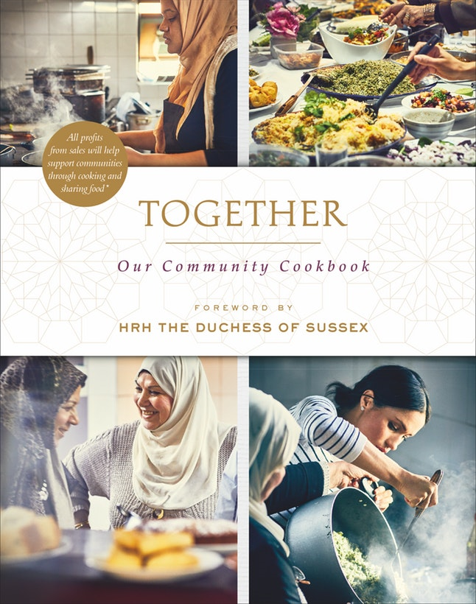

This resource can be used as the basis for a piece of work about living together within a ‘melting pot’ of culture in the UK today. The book is particularly poignant since it represents a range of recipes which mirror and echo the ethnic identities of many of the communities who were involved in these tragic series of events and it will act as a powerful prompt to the students studying Citizenship because they will be replicating a just and equitable society through the use of the recipes contained within the book itself. This will offer a creative and memorable approach to this area of study and will engage all students in a practical activity which will deepen their understanding of these central issues.

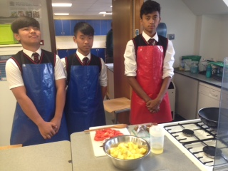

Summary and conclusion

The ideas contained with this chapter are of course steeped in the conviction that there is a lot of cultural capital to be found within popular culture which inevitably influences and shapes many young people’s lives today. In a way the connectivity that is represented by many of these aspects of popular culture is one of the greatest resources in your teaching repertoire. Citizenship, to be meaningful and in touch, must take into account the influences of popular culture upon young people and must engage each learner in such a way as to become relevant and profound.

It can be a difficult remit to fulfill because of the parameters and constraints that all teachers have to operate within currently, and this can be a real source of frustration at times. As stated elsewhere in this chapter, the current educational landscape has significantly shifted towards a model which is very prescriptive and outcome driven with very little space left for creativity and innovation. This is of course an open invitation to be even more creative and innovative since these curriculum constraints serve as grains of sand in the shell of the oyster, which over time inevitably, creates a pearl. The tensions that exist within the current curriculum can be used to define a moral purpose and intention behind an educational enterprise which seeks to innovate and to create educational opportunities which are unique and particular to Citizenship. These skills are also an integral part of a complete curriculum entitlement as well.

Citizenship can appear to lack a sense of relevance and can appear to be remote and out of touch with student’s concerns about life today. It would therefore seem necessary to suggest that the young people we teach do deserve the richest possible range of learning experiences that we can provide, that are both life changing and life affirming by creating a genuine sense of curiosity and inquisitiveness. In this way Citizenship is perfectly placed within the curriculum to meet this need and must out of necessity be viewed and framed through the lens of creativity. It is through creativity that Citizenship is made relevant and immediate and responsive to the needs of the young people it is serving and representing. It is clear that Citizenship needs to be rescued from mediocrity and from a sense of all pervasive ‘greyness’ and needs to be re-positioned with panache and finesse within a curriculum that is driven by a set of moral imperatives related to creativity and its importance.

Bibliography

Camus, A. (1991) The Myth of Sisyphus and other essays, First Vintage International Edition, USA, Random House, New York.

Cultural Learning Alliance (2018) https://culturallearningalliance.org.uk/ a whole host off reports on creativity and the curriculum accessed December 2018.

DCMS , Department for Culture, Media and Sport, (2016) https://assets.publishing.service.gov.uk/government/uploads/system/uploads/attachment_data/file/544103/DCMS_Sectors_Economic_Estimates_-_August_2016.pdf accessed November 2018.

Florida, R. (2004) The Rise of the Creative Class, Basic Books, New York.

Griffin, J, H (1996) Black Like Me, Signet Books, New York.

Harris, C. (2016) www.tes.com/news/our-curriculum-so-narrow-it-bores-both-pupils-and-teachers-and-crushes-creativity accessed December 2018.

Hubb Community Kitchen (2018) Together: Our Community Cookbook, Ebury Press, Random House, London.

Hyde, C, R, (2007) Pay It Forward, Black Swan Books, Transworld Publishers, London.

Hyde, L. (2008) Trickster Makes This World, Canongate Books, Edinburgh.

Imagine Nation Report: The value of Cultural Learning (2017) www.lahf.org.uk/resources/cla-imaginenation-report-benefits-arts-education accessed December 2018.

Judkins, R, (2016) You Are More Creative Than You Think, Sceptre Books, London.

McRobbie, A, (2016) Be Creative, Polity Press, Cambridge.

NASUWT (2017) Creativity and The National Curriculum www.nasuwt.org.uk/uploads/assets/uploaded/3535be2c-801c-46cb-b4410810472b52a3.pdf accessed November 2918.

NESTA Creativity and the Future of Skills (2018) accessed November 2018 www.nesta.org.uk

Sennett, R. (2008) The Craftsman, Penguin Books, London.

Voss, A, Wilson, S (2017) Re-enchanting The Academy, Rubedo Press, Auckland/ Seatle.

